**Scrap Trading System**

**Abstract:**

The Scrap Treading System is a platform through which we will connect scrap dealer/merchants with people who are possessing scrap in house and want to sell it at reasonable price. At this platform we will take description, type, quantity, photos of scrap from seller and put a post on website where other people [buyers/dealer] can explore it and can put bid for it. Then seller will decide who to sell according to various factors like price, pick up time, ease of transport, etc.

The main page of the website will contain various available post of scrap to be sold. Through this page anybody who is visiting this website will get to see these posts which will be ordered according to latest uploaded post in ascending manner. Various filters will be provided for sorting all post as buyer’s requirement. Filtering conditions like weight, price, type, material, locations etc. This page will also contain approximate current rates of different types of scrap material. The page will also provide Calculator as feature to the users to make their job easy.

For bidding user (buyer) must login first. If a user is not registered on the website, then they have to register first using register option. After successful login user can bid for scraps. Buyers or users may filter scraps according to various filtering conditions like weight, price, type, material, locations etc.

For uploading post to sell scrap Sellers also have to login first. If a seller is not registered on the website, then they have to register first using register option.

**Project module/Functionalities:**

1. Register
2. Login
3. Posts upload (sell)
4. Filters
5. Bidding Option (buy)
6. Seller confirmation (selecting suitable bid)
7. Calculator (Additional Feature)
8. Current Market price of Scrap various materials

**Current Scope:**

Through this platform we will be connecting Scrap sellers with buyers by providing them additions features for an interactive business and making them easy to tread. With value of scrap on which they both can agree.

**Future Scope:**

In future this system can also be added with additional feature like Online Payment Gateway, Online Transportation Booking and

360⁰ view of scrap.

**Use case diagram:**

**Use Case diagram for User**

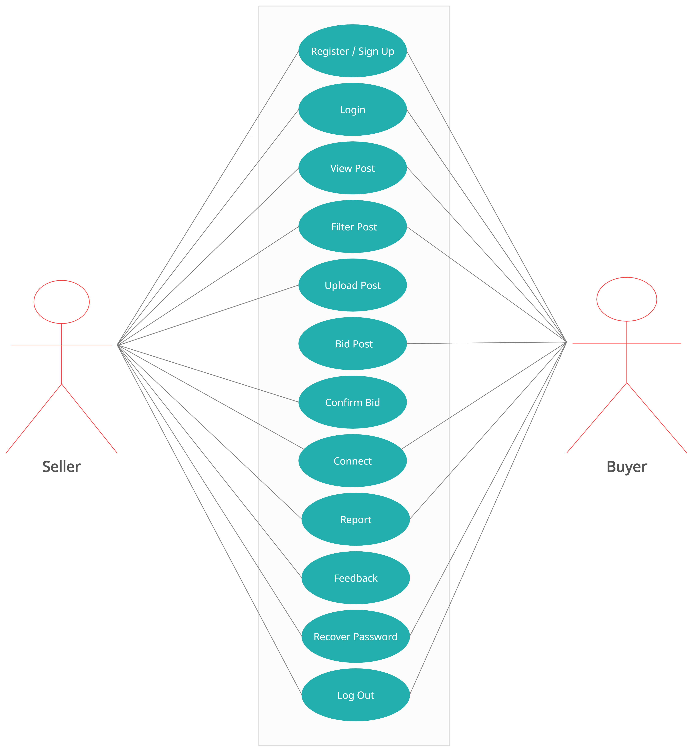

**Use Case diagram for Admin:**

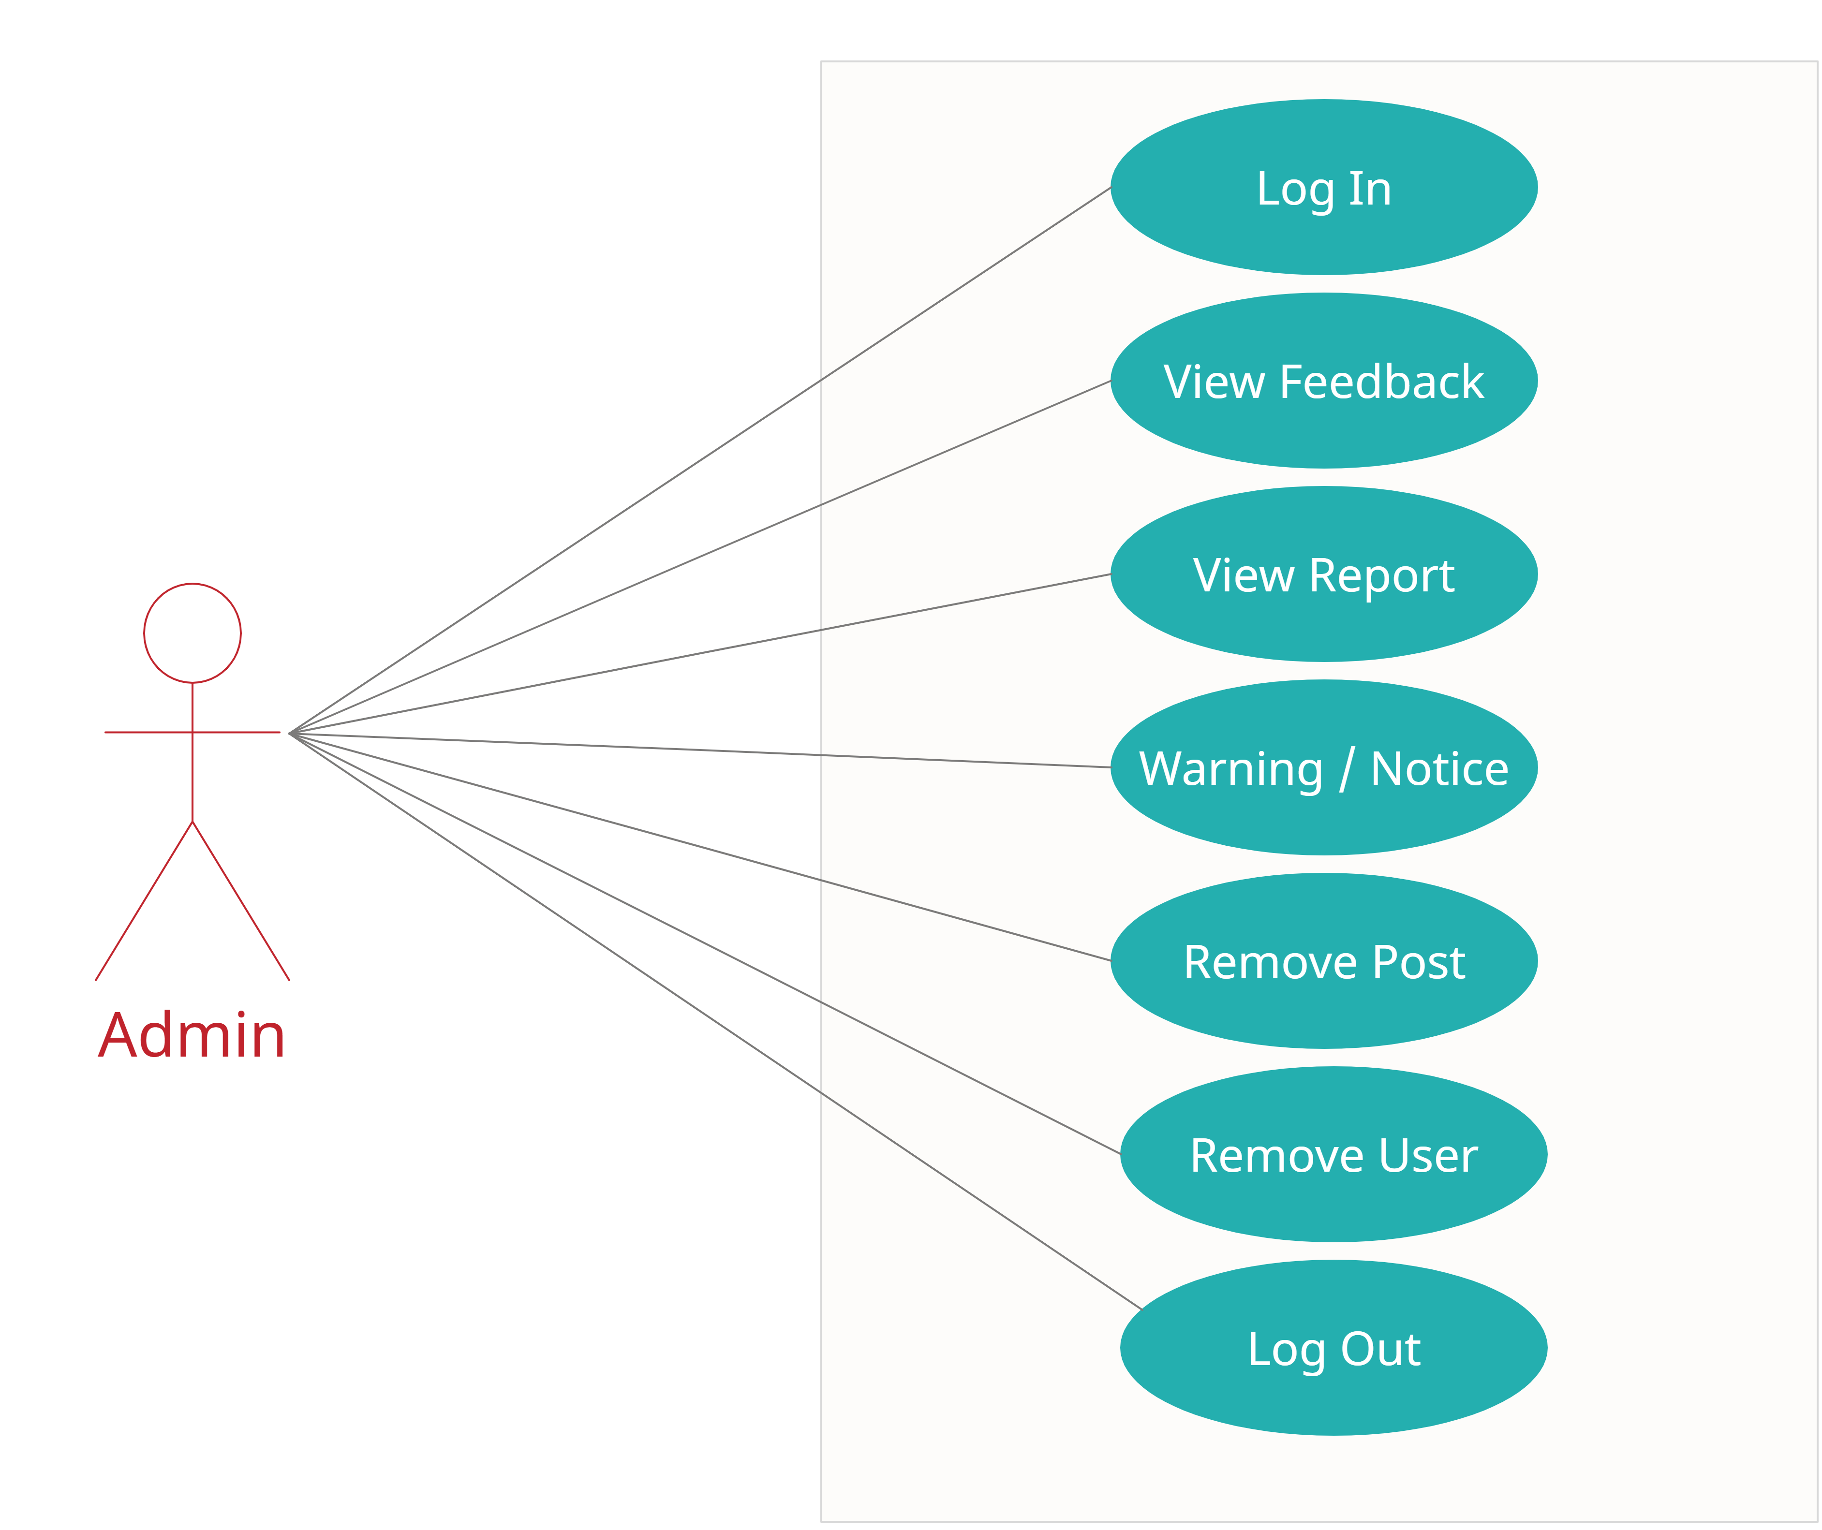

**ER Diagram :**

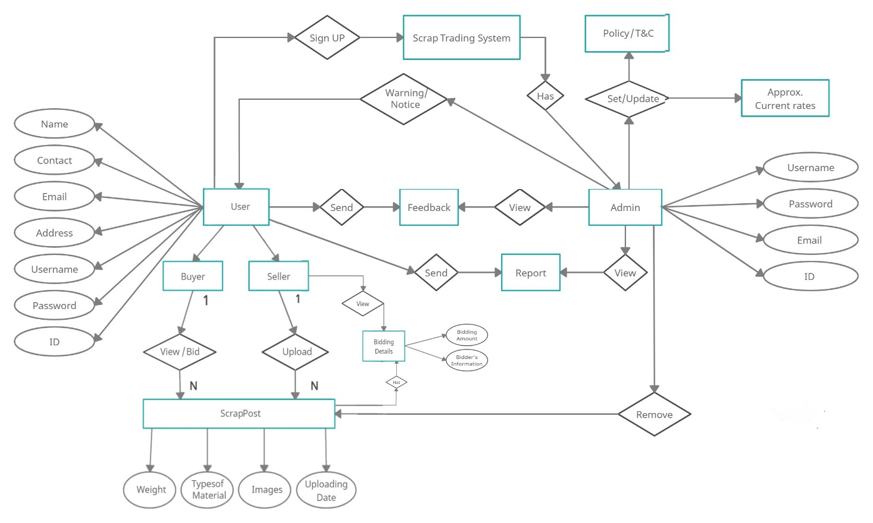

**--- G114 : Waman Ghosale(223065)**

**Kaustubh Karvekar(223090)**